**DATA STRUCTURES AND ALGORITHMS**

**EXERCISE 2: E-COMMERCE PLATFORM SEARCH FUNCTION**

**SearchUtil.java**

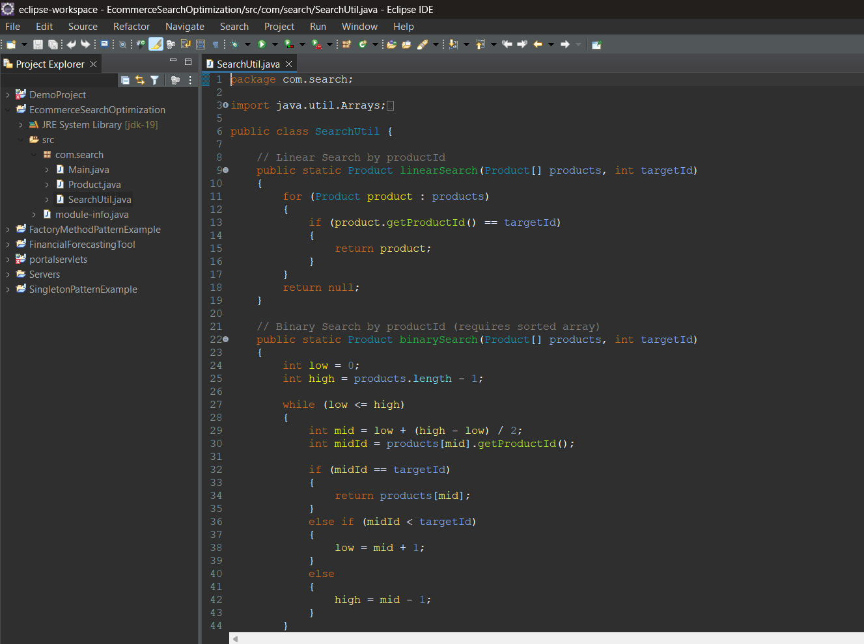

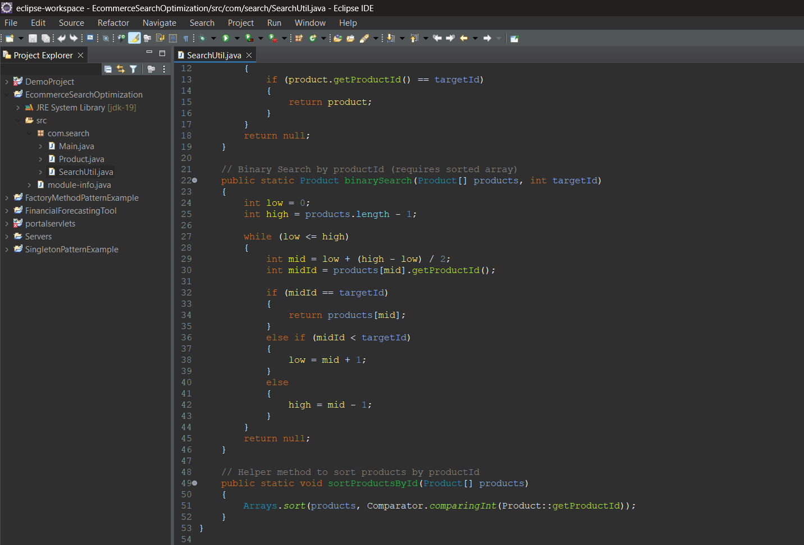

**Product.java**

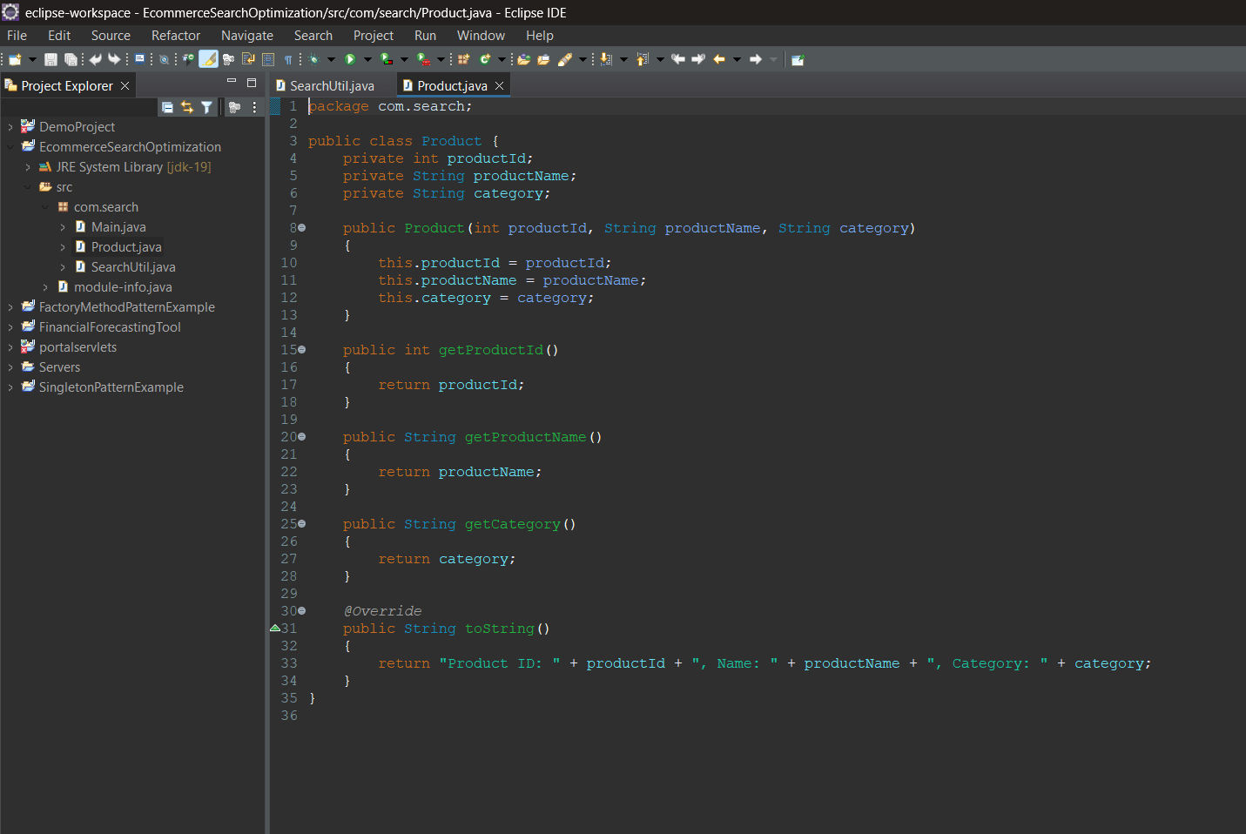

**Main.java**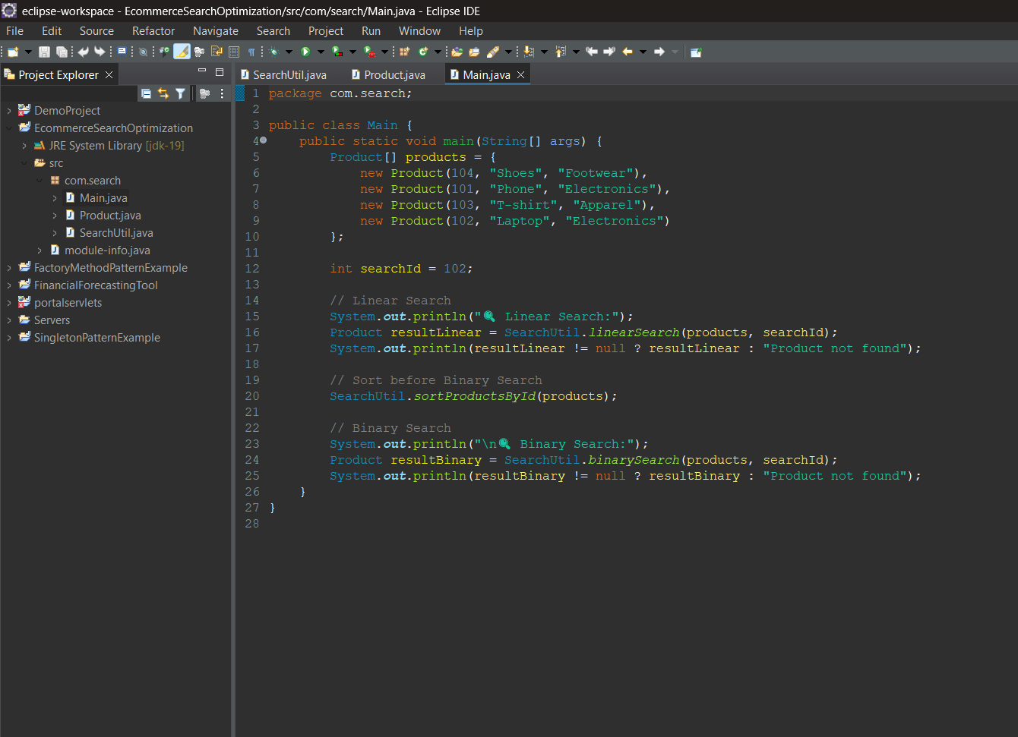

**Output:**

